***Query category: Spatial***

1. (Number) What is the total area of Tarrant county?

**SELECT** **AREA**(C.GEOMETRY) **AS** AREA **FROM** COUNTY_BOUNDARY **AS** C

**WHERE** CNTY_NM = 'Tarrant'



Result:

1. (List of counties -Text ) Which counties are located around Dallas county (share a

boundary with Dallas county)?

**SELECT** C1.PK_UID,C1.CNTY_NM **FROM** County_boundary **AS** C1, County_boundary **AS** C2

**WHERE** **TOUCHES**(C1.GEOMETRY,C2.GEOMETRY) = 1

**AND** C2.CNTY_NM = 'Dallas'

Result:

1. (Number) What is the total length of MATLOCK RD that is located in Tarrant county?

**SELECT** **sum**(**length**(r.geometry)) **as** TOTAL_LENGTH_MATLOCK_RD **FROM** roads_2017_u r

**where** r.full_name = 'MATLOCK RD'

**and** county_l = 'TARRANT'



Result:

1. Return the list of all roads that are totally inside Tarrant county boundary.

Note: some roads has more than one record, you need to do group by to return each road

name only once.

**SELECT** **DISTINCT** r.full_name **FROM** County_boundary c,roads_2017_u r

**WHERE** **WITHIN**(r.geometry,c.geometry) = 1

**AND** r.county_l = 'TARRANT'

Result :

1. (XY coordinate) Return the co-ordinates of the center point of Dallas county as text.

**SELECT** **astext**(**Centroid**(geometry)) **FROM** county_boundary

**WHERE** cnty_nm = 'Dallas'

1. (Number) Returns the dimension of the geometric object of Hood county?

**SELECT** **dimension(**geometry**)** **FROM** county_boundary

**WHERE** cnty_nm = 'Hood'

1. (List of roads) Return the names of the roads with class ‘PRIMARY HIGHWAY’ in

Tarrant county.

**SELECT** **DISTINCT** full_name **from** roads_2017_u

**WHERE** class = 'PRIMARY HIGHWAY'

**AND** county_l = 'TARRANT'

Result: 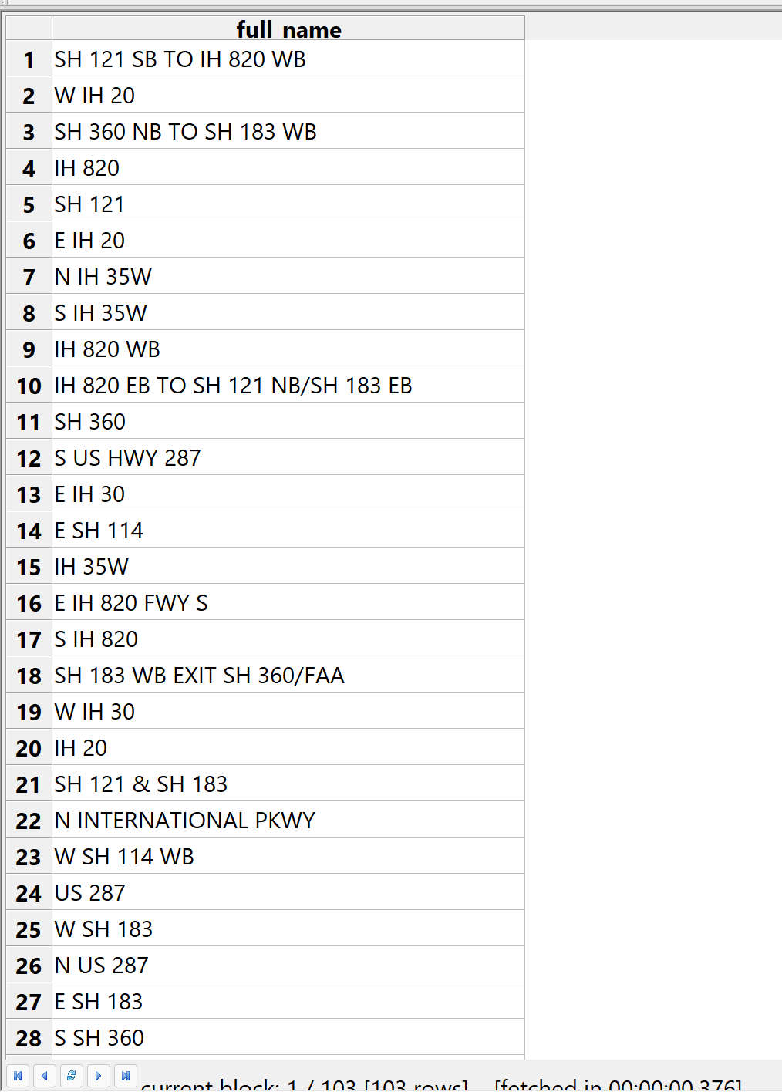

1. (List) Return all the roads that intersect with ‘S COOPER ST’ in Arlington

**SELECT** **DISTINCT** r1.full_name **FROM** roads_2017_u r1, roads_2017_u r2

**WHERE** **INTERSECTS**(r1.geometry,r2.geometry) = 1

**AND** r2.full_name = 'S COOPER ST'

**AND** r1.full_name != 'S COOPER ST'

**AND** r1.city_l = 'ARLINGTON'

**AND** r2.city_l = 'ARLINGTON'

Result:

1. (County name and size) Return the name of the largest county in size?

**SELECT** cnty_nm, **max(Area**(geometry)**)** **FROM** county_boundary

***Query category: Non-spatial***

1. (list) List the unique event types from WAZE data set.

**SELECT** **DISTINCT** EVENT_TYPE **FROM** DFW_WAZE_shap_file

**Result:**

1. (bar chart- only the result from the 2nd row to the 6th row) Return the WAZE event type

and total of each type that happened in Arlington on 12/08/2018 order from the largest.

**SELECT** event_type,**count**(event_type)**as** total **FROM** DFW_WAZE_shap_file

**WHERE** city = 'Arlington'

**AND** create_tim **LIKE** '2018-12-08 %'

**AND** close_time **LIKE** '2018-12-08 %'

**GROUP** **BY** event_type

**order** **by** total **DESC**

Result:

**SELECT** event_type,**count**(event_type)**as** total **FROM** DFW_WAZE_shap_file

**WHERE** city = 'Arlington'

**AND** create_tim **LIKE** '2018-12-08 %'

**AND** close_time **LIKE** '2018-12-08 %'

**GROUP** **BY** event_type

**order** **by** total **DESC**

**LIMIT** 1,5

Result:

1. (bar chart – only the result from the 1st row to the 3rd row) Return the WAZE event type

and total of each type that happened in Dallas on 12/25/2018 between 10:00:00 and

12:00:00 order from the largest.

**SELECT** event_type,**count**(event_type)**as** total **FROM** DFW_WAZE_shap_file

**WHERE** city = 'Dallas'

**AND** create_tim **BETWEEN** '2018-12-25 10:00:00' **AND** '2018-12-25 12:00:00'

**AND** close_time **BETWEEN** '2018-12-25 10:00:00' **AND** '2018-12-25 12:00:00'

**GROUP** **BY** event_type

**order** **by** total **DESC**

Result:

**SELECT** event_type,**count**(event_type)**as** total **FROM** DFW_WAZE_shap_file

**WHERE** city = 'Dallas'

**AND** create_tim **BETWEEN** '2018-12-25 10:00:00' **AND** '2018-12-25 12:00:00'

**AND** close_time **BETWEEN** '2018-12-25 10:00:00' **AND** '2018-12-25 12:00:00'

**GROUP** **BY** event_type

**order** **by** total **DESC**

**LIMIT** 0,3

Result:

1. (Table with event type and total) Retrieve total of each WAZE events that happened on

the third Sunday in Dallas city.

***Query category: Spatio-temporal***

1- (streets name) Return the street name and location of event with event type “accident”

that happened in Tarrant county on 12/09/2018 between 6:00 and 19:00?

**SELECT** **DISTINCT** facility_n,**astext(**geometry**)** **FROM** DFW_WAZE_shap_file

**WHERE** event_type = 'accident'

**and** county = 'Tarrant'

**and** create_tim **between** '2018-12-09 06:00:00' **and** '2018-12-09 19:00:00'

**and** close_time **between** '2018-12-09 06:00:00' **and** '2018-12-09 19:00:00'

2- (Number ) Retrieve the number of traffic jams in Collin county on 12/27/2018 between

7:00:00 and 15:00:00.

**SELECT** **count**(event_type) **FROM** DFW_WAZE_shap_file

**WHERE** event_type = 'traffic jam'

**and** county = 'Collin'

**and** create_tim **between** '2018-12-27 07:00:00' **and** '2018-12-27 15:00:00'

**and** close_time **between** '2018-12-27 07:00:00' **and** '2018-12-27 15:00:00'

Result: